NSU E-Canteen: An Online Food Delivery System for the Faculty Members of NSU

Hasna Hoque Mitu, Ibrahim Chowdhury, Parijat Datta, Tanvir Mahtab  
*ECE Department*North South University  
Dhaka, Bangladesh

***Abstract*—** ***Our proposed system is an online food ordering system that enables ease for the faculties of North South University. It overcomes the disadvantages of the traditional system of going to the canteen for buying food. Our proposed system is a medium to order online food hassle free from current restaurants of NSU canteen. This system also tries to improve the method of taking the order from a customer. The online food ordering system sets up a food menu online and customers can easily place the order as per their wish. Also with a food menu, customers can easily track the orders. This system also provides a feedback system in which user can rate the food items. Also, the proposed system can also manage the orders efficiently. And only the verified customers can enter into the system and only the orders approved by admins will be added to the list. The payment can be made pay-on-delivery system. And unlike other delivery systems, there will be no constraint like minimum amount order, timing and so on. For more secured ordering, separate accounts are maintained for each user by providing them an ID and a password. Admins can manage the accounts, customize the food menu, and order list.***

***Keywords: web-based application,***

# INTRODUCTION

Online food ordering system is one kind of web-based application for customers to provide a more interactive menu so the process of ordering could be generated easily. It is designed for in a flexibility way so that the system has enough function through information or picture to guide customer like students follow the steps to finish the ordering food process. Besides, it has been implemented in such a way to deal with a large number of orders simultaneously to prevent overloading problem. Basically, online food delivery system is designed for university users to supervise for good performance and better services due to lack of their time.

All over the world, the food delivery already account for the £83 million, the only percent is formed general food market and inclusive of the four percentage restaurant and fast food chains, in many mature nations, this range of growth fee will constantly to growth at 3.5percent in the subsequent five years, by using some distance, the conventional category that looking forward to the restaurant to convey the food to the patron has stood ninety percent, however almost 3-quarters are using

through telephone (Hirschberg et al., 2016).

In this astonishing rate of online ordering may still hide some disadvantage or problem need to handle it, such as website costs, infrastructure cost, security and fraud, privacy laws, computer ethics, advertising cost and customer cost (nibusinessinfo.co.uk, 2015).

In university, respected faculty members don’t have proper schedule due to variable timetable and pressure during the examination process. This could be more difficult to decide when and where to have finished their meal. Also, they need to waste enough time to get food through university canteen.

To solve this problem, we are going to develop an online-based system, which is designed for mainly faculty members of the university. Using this system, they can easily order their food from university canteen through the website. The main purpose is designed user-friendly and time saving online food ordering system for university faculty members.

# RELATED Works

Tradition food order process used in most full-service restaurants starting when a waiter brought the guests the paper-based menu, and then waiting for the guests to choose items from the menu and inform the waiter the order items. The process typically required the guests to be seated in the restaurant and a waiter to assist the ordering .One of the most widely used food ordering system is the conventional paper based system. In this system all records are stored on paper. The main drawback of this system is papers can get easily lost or damaged. There is also wastage of money, time and paper. Paper-based systems do not provide any form of dynamicity. Even a small change requires the re-print of entire menu-card. Also large amount of human efforts are required, this system is not work properly because it has some error and from a customer’s point of view it is time consuming. [1].

Self-service restaurant process required the guests to place order at the service counter in the restaurant. The guests shall have decision in advance, before presented at the counter, of which menu items to order. Menu catalog is mostly presented as posters placing behind the order counter. [2]

In order to reduce service cost and enhance customer experiences, few restaurants have invested in the service automation system. The automation system used to capture the food order from guests ranged in many forms but mostly comprise of an electronic device with a screen presenting the menu and accept user’s input for order placing First waiter takes the order from customer. After taking the order, waiter should enter that order in system where PC was set up. At the kitchen information was displayed on screen. The kitchen staff would then prepare the dishes according to order and after completion of order they would inform to waiter, who collected and delivered the dishes to the respective tables. The system was also informing the waiter about the availability of a dish. If a certain dish was not available then waiter was able to ask for changes or even cancel a customer’s order. After serving the order, bill was generated at the cash counter as per customer order. The management had full authority to access all details of the customer which are fed into the system. With the improvement in the computer and communication technology, various systems were launched in market for the purpose of computerization of the food ordering system. [3].

Electronic Menu Card for Restaurants order system overcome the drawback of traditional paper based order system, it change everything from paper based into computerized. First of all, the system will be programed with the food availability from the respective restaurant and display on touchscreen devices that have been setup in each of the tables within the restaurant. In addition, the touchscreen device will have a very attractive Graphic User Interface (GUI) that displays the food menu for customer to make their choices and enable customer to place an order by touching the particular food image that display on the device screen. Next, when the customer placed an order, the food order will be send to the kitchen and the chef can prepare for the food. This system eliminates the issue from traditional paper based system that the waiter has to manually deliver the order to kitchen. Other than that, the system provide a sub-module that enable restaurant owner to update the food details, food price and etc. It was very convenience compare to the traditional paper based system, because paper based system require the restaurant owner to dispose all old food menu cards and re-print the latest food menu card to serve their customers. [4].

The present online ordering food economy allow users to apply a single tap of their mobile phone to order from a wide array of restaurants, so the team want to checking some literature to understanding in what reason online food delivery are quite important for people in this century. this section should situates the team research ,which is need focus on the wider academic community in the online ordering food and to identify the gap within that the literature that the research will be need to address. and the main purpose of literature review is that combine with understanding of each work, point that in which way could fulfilling the need for other research, and located the team own design in the background of existing literature is the most significant point (Ridley and Diana, 2012), through the further study of tracing the intellectual progressing, the team could ability to accumulate the methods of research and study in the literature, and it also as a basic step to be contrast consider and analysis the existing system, and give the positive feedback about the problem that existing system could not be solve it. Hence, following parts will through APP design integrity, specification, use requirement, common issues and emerging technology to analysis the role of online food delivery system in markets. [5].

# Program Requirements

## Function

In the e-canteen system, we have few functionalities. They are:

1. Food add
2. Food availability
3. Food delivery
4. Food order
5. User authentication
6. User add
7. User modification
8. User confirmation
9. Online supporting system

## Flow Chart

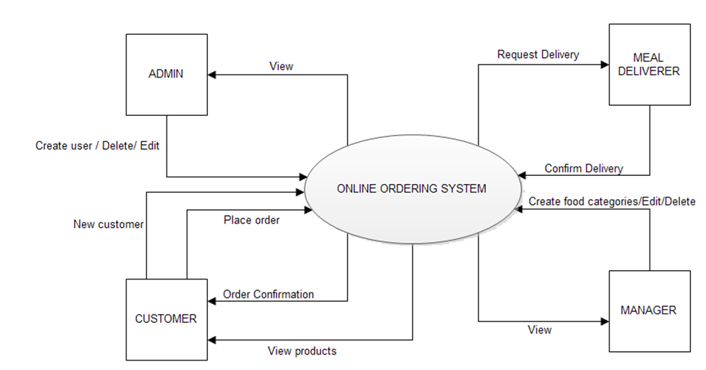

Figure 1. Flow chart

Above flow chart, admin can create a user, confirm user and delete the user. Admin will have all the power in the system. Admin will add foods and will ensure the availability of the food.

After delivery, an order admin will make it as delivered. So the client can see their order is on the way. At this time admin is the meal deliverer. Admin will confirm the delivery system.

The customer has to be an account to use the e-canteen system. The customer can only see the available food and make an order. The customer also sees the order that is delivered or not. In every order, the customer has to confirm his/her delivery location.

Admin will also act as a manager. The customer can ask any question or queries about the system or food using the ticket system. Every query will be answered by the admin. There can be multiple admins on a role basis.

## ER Diagram

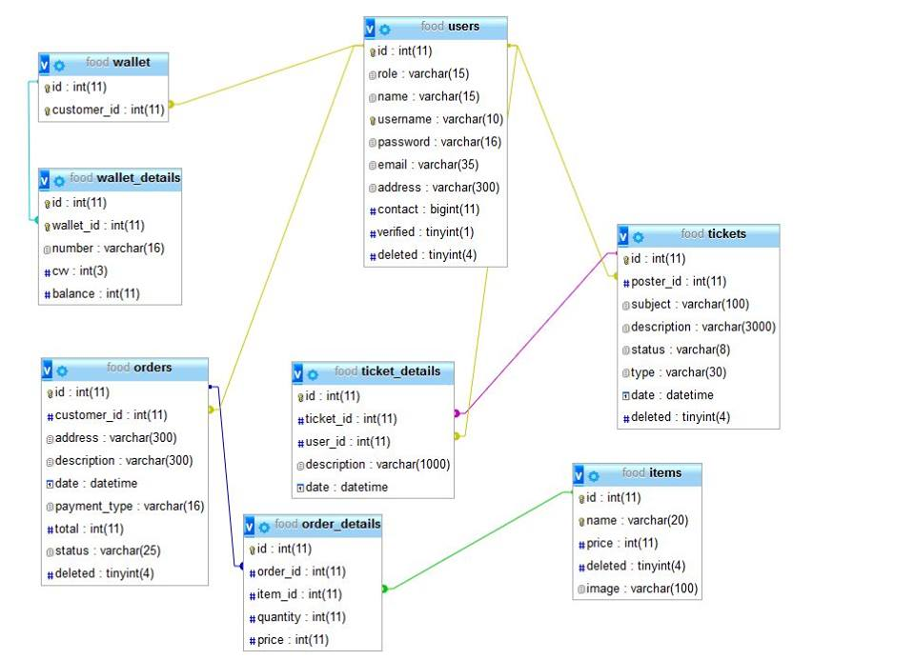

Figure 2. ER Diagram

Above ER diagram shows the connection between table, primary key and foreign key. It helps to create our database properly.

# Implementation

To implement the e-canteen system, we needed the knowledge of HTML, CSS, BOOTSTRAP, PHP, JAVASCRIPT, and SQL. HTML is needed to make this system for the web platform. To design the system we used BOOTSTRAP. Because BOOTSTRAP makes the platform responsive so that it can adjust to any device whether it is mobile, tab or big screen computer.

To connect our website with the database we used PHP. PHP is also a language. Using PHP we can easily get the data from the database and also we can store the order to the database using PHP. TP get proper data we use SQL. Using SQL query we can store data to the database and get data from the database.

To make the website more secured we used JAVASCRIPT. JAVASCRIPT is a great language for security. Using JAVASCRIPT we can verify every data input from users.

# Performance Requirements and consideration

## Speed

It ensured that all queries and execution time of the PHP scripts should be less than a second. This is to ensure that the user will not be waiting too long for the application server to execute the script.

## Security

Hashing technique was employed in the login system component of the site. When a login name is being inputted, the value of the password will be hashed first using MD5 cryptographic hash function before being stored into the database.

## Portability

It is also considered in the development that the website is compatible to the following browsers: Mozilla Firefox 30 or higher versions, Opera 8.5 or higher versions, or Internet Explorer 8.0 or higher versions.

# Interface

I. Main Interface:

Figure 1 shows the main interface. It’s basically includes login and register page. User (Faculty members) can easily login the page to proceed next step. Also, new user need to register food ordering by giving information like name, password, and phone number.

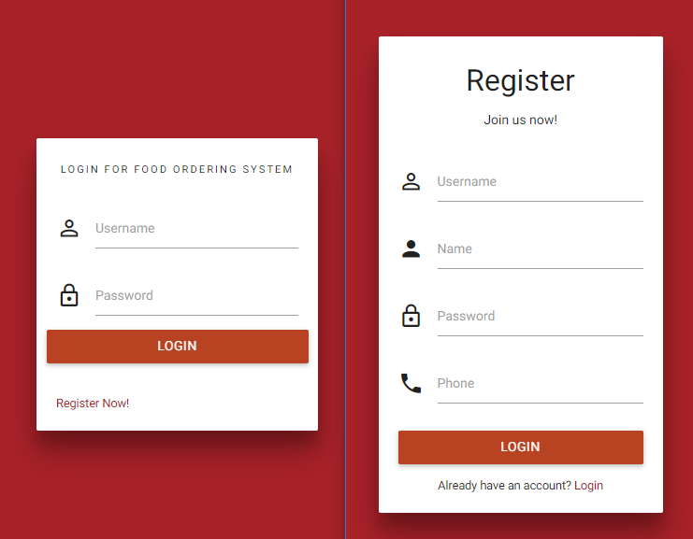

Figure 1. Screen Shot: Main Interface

II. User Interface:

After login the page, user can see figure 2 interface. They can easily order the food and, also view the order of history. They can also cancel the order within a time.

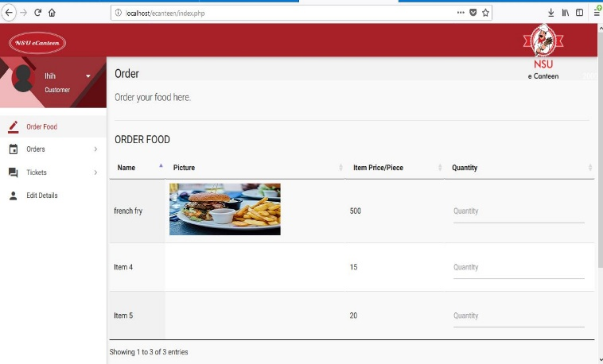

Figure 2. Screen Shot: User Interface

III: Admin Interface:

Figure 3 shows the admin interface. Admin has the option to add items by giving name, image, and price of each item. Admin also see the order history and list of user easily. Only Admin can able to verify the user by seeing proper information.

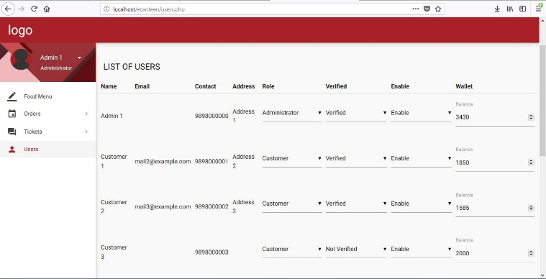

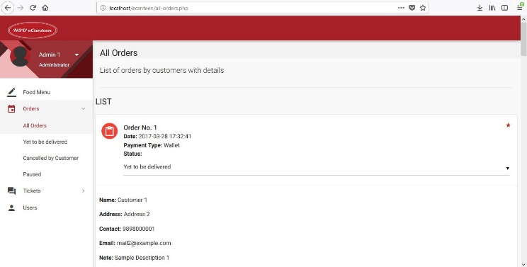

Figure 3. Screen Shot: Admin Interface

# Conclusion

Online food delivery service is very important for our daily life. Therefore, the proposed system is based on user’s need and is user centered. The system is developed in considering all issues related to all users which are included in this system. Wide range of people (faculty members and students) can use this by operate the website and apps. Various issues related to Tiffin Service will be solved by providing them a full- fledged system. Thus, implementation of NSU Online Food Ordering system is done to help and solve one of the important problems of faculty members and students. It helps customer in making order easily; it gives information needed in making order to customer. The Food website application made for NSU food shop and mess can help food shop and mess in receiving orders and modifying its data and it is also made for admin so that it helps admin in controlling all the Food system. With online food ordering system, a food shop and mess menu online can be set up and the customers can easily place order. Also with a food menu online, tracking the orders is done easily, it maintain customer’s database and improve the food delivery service. The NSU food shop and mess can even customize online food shop menu and upload images easily. Having a menu on internet website, potential customers can easily access it and place order at their convenience. Thus, an automated food ordering system is presented with features of feedback and wireless communication. The proposed system would attract customers and ads to the efficiency of maintaining the food shop ordering and billing sections. Scope of the proposed system is justifiable because in large amount peoples are coming to the university from the long distance so wide range of people can make a use of proposed system.

# Future work

Here are some primary goals for future direction-

1. To include the restaurant’s outside of NSU: In our NSU online food delivery system we mainly include our university canteen food shop. But in future our plan is to include varieties of restaurants outside of NSU which will help to get more quantity of food supply and quality food. This will also help the customers to get food in cheap price.
2. To increase the food varieties: In future if we include more restaurants in our system then we will get varieties of food from different restaurants. Every restaurant has different menu for foods so anyone can get any kind of food easily.
3. To include students as well: Our first plan is to serve good quality food easily for the faculty members. But in future we planning this for the students. This will help the students to get good quality and varieties of food in their range. So the students don’t need to go outside the university.
4. To make a Mobile Application: The customers can order food only in website. But in future we plan to create a mobile application which will help customers to order their food through apps and get their food delivery faster.
5. To include more payment option so that it becomes always hassle-free for user.
6. To include machine learning base food recommendation system.
7. Customize orders: Allow customers to customize food orders.
8. Enhance User Interface by adding more user interactive features. Provide Deals and promotional offer details to homepage.
9. Payment Options: Add different payment options such as bkash, rocket, credit card etc. Allow to save payments details for future use.
10. Allow to process an order as a Guest.
11. Order Process Estimate: Provide customer a visual graphical order status bar.
12. Order Ready notification: Send an Order Ready notification to the faculty members and students.

# Acknowledgment

For this project, we would like to thank our honorable faculty **Mr. Zunayeed Bin Zahir**, Department of Electrical and Computer Engineering (ECE) North South University to inspire us to make a good Project. It is very helpful in our future life.

References

[1].VarshaChavan,PriyaJadhav,SnehalKorade,PriyankaTel iProf.Mr.R.B.Anpat”Implementing Digital Restaurant and Inter-Restaurant Navigation Using Smart Phone”,inInternational Journal of Computer Science and Mobile Computing,Volume 4,Issue 2 February 2015.

[2]. Apurva Joshi, PrachiOke, NiranjanJadhav, AshutoshBhargave Prof. Mr. S. R Lahane, “Digital Ordering System for Restaurant using Android”, in International Journal of Scientific and Research Publications, Volume 3, Issue 4, April 2013.

[3].M. Firdouse Ali Khan, Swapna, “Design and Implementation of Ordering System for Restaurants”, in International Journal of Engineering Research & Technology (IJERT), Vol. 1, Issue 10, December- 2012.

[4].R.Bora, P. and Gupta, E. (2012). *APPLICATION ON ORDER MANAGEMENT SYSTEM IN RESTAURANTS*. [online] www.ijaiem.org. Available at: http://www.ijaiem.org/volume1Issue2/IJAIEM-2012-10-15-027.pdf [Accessed 16 Nov. 2014].

[5].Ridley and Diana (2012). *Research Guides: Organizing Your Social Sciences Research Paper: 5. The Literature Review*. [online] Libguides.usc.edu. Available at: http://libguides.usc.edu/writingguide/literaturereview [Accessed 21 Nov. 2017].

[6]. Hirschberg, C., Schumacher, T., Wrulich, M. and Rajko, A. (2016). The changing market for food delivery. [Online] McKinsey & Company. Available at: https://www.mckinsey.com/industries/high-tech/our-insights/the-changing-market-for-food-delivery [Accessed 26 Oct. 2017].

[7]. nibusinessinfo.co.uk. (2015). Advantages and disadvantages of online retail. [Online] Available at: <https://www.nibusinessinfo.co.uk/content/>

[8].Sun Guiling; Qingqing Song, "Design of the Restaurant Self-Service Ordering System Based on ZigBee Technology, “Wireless Communications Networking and Mobile Computing (WiCOM), 2010 6th International Conference on, vol., no., pp.1,4, 23-25 Sept. 2010.

[9]. M.H.A. N. Ahmad, A.A. Mutalib H.A. Kadir, Wahab and M.F.M. Mohsin, “Implementation of network-based smart order system,” International Symposium on Information Technology 2008 (ITSim 2008), pp. 1-7, 2008.

[10].Hashim,NikMohdZarifie and Ali,Nur Alisa and Ja'afar,AbdShukur and Mohamad, NajmiahRadiah and Salahuddin, LizawatiandIshak, Noor Asryran (2013) Smart Ordering System via Bluetooth. International Journal of Computer Trends and Technology (IJCTT), 4 (7). pp. 2253-2256.

[11]. M. ErdiAyob, Ayob J., Mohd. Helmy A. Khairunnisa K., Wahab, M. IzwanAyob, M. AfifAyob “The Application of Wireless Food Ordering System,” MASAUM Journal of Computing, Volume 1 Issue 2, September 2009,pp 178 -183.